**Labour market status of VET graduates in Georgia**

**Analysis of tracer studies**

**VET Department**

**Ministry of Education and Science**

**Tbilisi**

Contents

Introduction 3

Data Sources and Methodology 4

Description of the main findings 6

Summary 7

Graduates Employment 17

Job placement 17

Job search channels 19

Skills mismatch on the job 23

Need to acquire further skills and competencies 23

Income on the job 25

Job satisfaction 27

Conditions of work 28

# Introduction

The presented report represents the first volume in the series of descriptive and analytical reports prepared by the Ministry of Education and Science (MoES) of Georgia with the aim to disseminate to wider public the findings of VET tracer studies and other relevant labour market information gathered by the MoES.

Tracer studies of VET school graduates are carried out by respective agencies of MoES as a part of the Government effort to improve the quality of VET and to contribute to the development of LMIS in Georgia.

Tracer study Concept Note and a corresponding Roadmap represented conditionality for the provision of EU technical assistance and direct budgetary support for VET and labour market development in Georgia. The Roadmap envisaged, among other measures, introduction of regular tracer studies among the VET graduates in order to monitor their labour market integration and to provide feedback that could be used by the VET providers to improve the quality and labour market relevance of the VET education.

The graduates’ study is the retrospective view on developments, as well as the tool for assessment of vocational results which includes systematic analysis about the important and long-term changes (positive or negative; planned or unplanned), which took a place in lives of the graduates.

Tracer Study is the best mean for measurement, assessment and description of the long-term learning outcomes. The study gives the information on how the graduates’ further activity was carried out in different directions (education, employment).

# Data Sources and Methodology

The tracer study cover graduates of 2012-2013 academic year of all public VET schools that are registered in the Education Management Information System (EMIS) of the ministry. Each graduate will be contacted every 6 months following his/her graduation during 2 years. The first stage of the study included the phone interviews, carried out by the MoES information centre staff being trained by the specialists of research and assessment division of Administration Department of the Ministry.

**The tracer study goals are:**

* Documentation of the changes, which took a place after graduation in beneficiaries’ lives.
* To determine whether the intervention supported the changes, namely, the changes were conditioned by the intervention, or – other factors.

**The objectives of tracer studies are:**

* Collecting the personal information on graduates after-education (employment / self-employment and continuation of study); professional orientation result in determination of the graduates’ following activities;
* Connection with the obtained qualification in case of continuing the education; information on the post graduate employment (company / organization, the connection with the obtained qualification, the means for searching the job, working conditions, salary and satisfaction with the employment, the stability of the job);
* Information on private business / family business / self employment after the study (company / organization, the connection with the obtained qualification, the means for searching the job, working conditions, salary and satisfaction with the employment, stability of the job);
* Information about education follow up activity (the reason for unemployment, motivation of the job seeking);
* Identification of the factors, which supported the changes (employment / self imployment and study continuance);
* Evaluation of the education intervention.

Tracer studies are based on standardised questionnaires administered in the course of phone interviews. (structured questionnaire, uploaded on the web page: poll.vet.ge). before finalizing the questionnaire, it passed several piloting phases. The final questionnaire contains 118 questions. The core questions are split into nine modules dedicated to several groups of respondents depending on their current status as follows:

(a) Studying at higher educational institution,

(b) Studying in VET institution,

(c) Working,

(d) Started own business,

(e) Involved in family business,

(f) Intern,

(g) Unemployed,

(h) Back to school and

(i) Other.

Each respondent could choose maximum three of above mentioned statuses (under (a) to (i). Each respondent answered 23 general questions and further 3 to 17 module-specific questions (in case of three modules there can be as many as 51 module-specific questions, depending on the combination of modules). The information, collected through interviews, is supplemented by the data from the EMIS databse. Respondents were informed about the anonymous character of the survey and confidential handling of any personal information. Consequently, all the collected data were anonymised for the analytical purposes. Data privacy is ensured by the secure handling of collected data and their storage at the dedicated protected servers of the MoES.

The first round of tracer study was launched during the fall of 2014. Total population of VET graduates in the academic year 2012/2013 included 2881 persons, from public VET schools, that were registered in the EMIS database.

The response rate of the first survey was 45 per cent. The non-response was caused by the impossibility to contact the graduates or to find out their whereabouts and by the refusal to participate in the interview.

The data obtained was analyzed through „MS excel“and „SPSS 21” programs.

The results are classified by the main variables of interest, such as gender, type of school, type of VET program/profession, urban/rural environment, region, etc.

The data allows for analysing several labour market indicators of interest, such as, for example:

* Job placement,
* Job search channels,
* Skills mismatch on the job,
* Need to acquire further skills and competencies,
* Income,
* Job satisfaction,
* Conditions of work, etc.

These or other indicators can be studied according to various group characteristics, such as:

* Educational program/profession
* Type of school
* Gender / Age
* Current labour market status, etc.

# Description of the main findings

* 84.9% of the interviewed graduates are satisfied with the chosen vocational educational program and 92.2% demonstrate the satifaction with the chosen vocational educational institution;
* 42% of the interviewed graduates are employed;
* 89% of the employed are partially or completely satisfied with their activities;
* Almost the half of the graduates (42%) states, that their activity is partially of completely in connection with the profession obtained in vocational institution;
* The majority of the vocational programs graduates– 85% - did not changed the residing place because of the job;
* More than a half of respondents are male (64%);
* 37% of the interviewed graduates obtained the information about the employment in vocational institution;
* 8.7% of the interviewed graduates continued the study at vocational educational institution, at higher educational institution or general schools.

# Summary

The study covered all the educational institutions existing throughout Georgia. 1,310 graduates of vocational programs of 2012 / 2013 took part in studies, 815 of which were male respondents, and 495 were female. The average age of the graduates was 24, the most common age is 20 (see table #1).

**Table #1 –** The age of the respondents

|  |  |
| --- | --- |
|  | **age** |
| Mean | 24 |
| Minimum | 17 |
| Maximum | 63 |
| Mode | 20 |

The number and relevant percent of the respondents participating in the studies according to the vocational colleges are provides in the table #2.

**Table # 2 -** The number and relevant percent of the respondents participating in the studies according the vocational colleges

|  |  |  |
| --- | --- | --- |
| **Vocational institutions** | **Frequency** | **Percent** |
| LEPL Community College „Mermisi“ | 264 | 20.2 |
| LEPL Vocational College „Modusi" | 208 | 15.9 |
| LEPL Community College „Spektri“ | 195 | 14.9 |
| LEPL Community College „Iberia“ | 149 | 11.4 |
| LEPL Vocational College „Balck Sea“ | 119 | 9.1 |
| N(N)PL Vocational College „Prestige“ | 87 | 6.6 |
| N(N)PL Vocational College „Horizonti“ | 72 | 5.5 |
| LEPL Vocational College „Phazisi“ | 57 | 4.4 |
| LEPL Community College „Akhali Talgha“ | 36 | 2.7 |
| Tkibuli Mining Tehcnological Institute of the Georgian Technical University | 33 | 2.5 |
| N(N)PL Vocational College ,,Ikarosi“ | 24 | 1.8 |
| Education Management Information System | 18 | 1.4 |
| LEPL Vocational College „Lakada“ | 15 | 1.1 |
| N(N)PL Vocational College ,,Gantiadi“ | 15 | 1.1 |
| LEPL Shota Meskhia Zugdidi State University | 9 | 0.7 |
| LEPL Samtskhe-Javakheti State University | 4 | 0.3 |
| LEPL Batumi State Maritime Academy | 3 | 0.2 |
| LEPL Community College ,,Aisi“ | 2 | 0.2 |

The majority of the respondents – 73.9% - are single; 24.7% - are married. The marital status of the graduates is provided in Table #3.

**Table #3 –** The marital status of the graduates[1]

|  |  |  |
| --- | --- | --- |
|  | **Frequency** | **Percent** |
| Single | 964 | 73.9% |
| Married | 322 | 24.7% |
| Divorced | 16 | 1.2% |
| Widow | 2 | 0.2% |
| Total | 1304 | 100% |

24.8% of the respondents are socially vulnerable status holders, but 6.5% are internally displaced persons. Figure #1 shows the percentage distribution of graduates according to mentioned social status, which reveals that the majority of the graduates – 68.3% - do not match any social status.

**Figure #1 -** Tracer social status (N= 1291)

The majority of the respondents – 1100 – did not the change the residential place because of the study on vocational programs, and only 193 (see figure #2) changed the residence.

**Figure #2 –** Change the place of residence for the purpose of education (N= 1293)

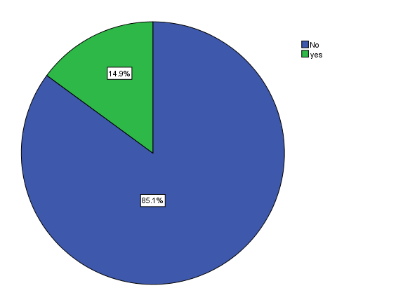

It should be noted, that the majority of the respondents, 1, 097 (84.9%), would have chosen the same profession, what shows the content of the vocational educational program. And also the majority of the respondents 1,189 (92.2%) demonstrated the satisfaction with the vocational educational institution (the percentage distribution of the data is provided in figures #3 and #4).

**Figure #3 -** Re-choice of profession (N= 1292)

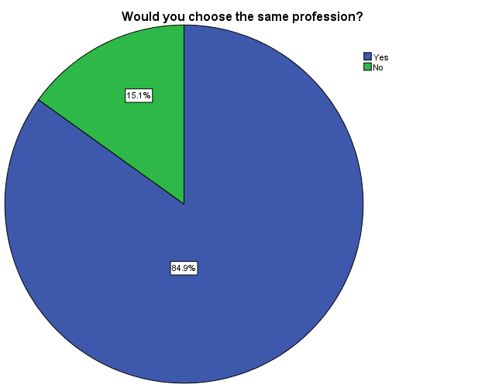

**Figure #4 –** Re-choice of the vocational institution (N= 1290)

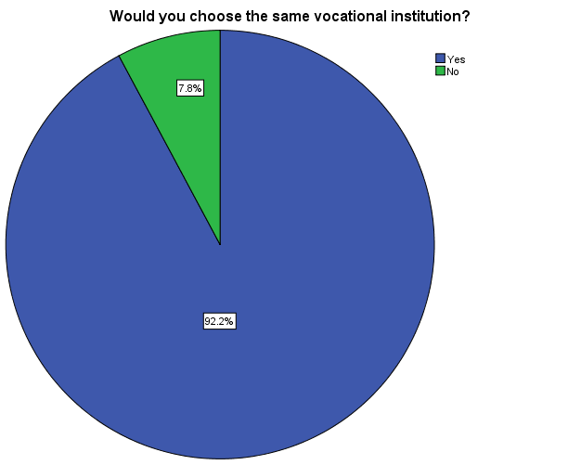

Graduates’ satisfaction in relation with different aspects of the obtaining the vocational education has been studied, the evaluation of which was carried out through the three-point system. As closer is the satifaction index to 3, i.e. to the highest evaluation, more satisfied the graduates are with the named educational aspects, and as close is to 1, the more unsatisfied they are. Based on the results, we may say that the level of the satisfaction of the graduates in respect to different aspects of obtaining the education is high enough: the average indicator is close to 3 in most cases. As the results show, the graduates are satisfied with the relationships of lecturers and students and with the qualification of the teachers, the average indicators of this data equals to 2.97 and 2.94. They are the most unsatisfied with the employement care, in this case the indicator is less than 2, namely, 1.81. the satisfaction of the students with the different aspects of the vocational education is provided in the Table #5.

**Figure #5 -** The satisfaction of the students with the different aspects of the vocational education (N= 1253)

The results conducted about the activity of vocational programs graduates – employment / self employment and study – are provided on figure # 62.

**Figure #6 -** Activity of the graduates (N=1211)

The activity of the respondents according the gender is provided in the figure #7.[2]

**Figure #7 -** The activity of the respondents according the gender (N=1211)

Percentage distribution of graduates according to the different field directions of the educational programs obtained by them and according to their current activity is provided in Table #4

**Table #4 -** Percentage distribution of graduates according to the different field directions of the educational programs obtained by them and according to their current activity

|  |  |  |  |  |  |  |  |
| --- | --- | --- | --- | --- | --- | --- | --- |
| Field / activity | Agricultural Sciences | Business Administration | Engineering | Natural sciences | Interdisciplinary fields | Art | Health Care |
| Studying in high school | 0.7% | 2.2% | 6.5% | 0 | 0 | 2.9% | 0 |
| Studying for vocational programs | 7.2% | 10% | 4.7% | 12.5% | 5.9% | 6.8% | 10% |
|
| Works | 41.7% | 35% | 34.8% | 50% | 47.1% | 29.8% | 26.7% |
| Has own business | 0 | 3.75% | 0.6% | 0 | 0 | 3.7% | 0 |
| Intern | 0.7% | 1.3% | 0.8% | 0 | 0 | 0 | 0 |
| Involved in households | 2.9% | 1.3% | 1.4% | 0 | 0 | 0 | 0 |
| Is unemployed | 42.4% | 31.3% | 48.8% | 37.5% | 43.7% | 51.6% | 43.3% |
| Is back to school | 2.2% | 0 | 1.2% | 0 | 0 | 0 | 0 |
| Other | 0 | 0 | 0.6% | 0 | 1.7% | 3.7% | 0 |
| Total | 97.8% | 84.85% | 99.4% | 100% | 98.4% | 98.5% | 80% |

Horizontal column of the table presents the sectoral trends, the relevant professional training programs of which have been passed by the surveyed respondent. Vertical column, gives the current activities. It seems that most of the employees are involved in the Agricultural Sciences, Business Administration, Engineering, Natural Sciences and Interdisciplinary fields of training program graduates.

It should be noted that 6.3% of all specialty graduates continue study on vocational programs. 1.4% want to continue studying in higher educational institutions and 1% is back to school.

Most of the graduates (59%), who are pursuing their studies at the institutions of higher education or vocational education, study at the vocational or higher educational programs which are partially or directly in connection with the profession obtained at vocational institution. (see. Table 5)

**Table #5** – Quantative and percentage distribution of the graduates according to the connection of the qualification obtained at vocational institution with the current educational program.

|  |  |  |
| --- | --- | --- |
|  | **Frequency** | **Percetnage** |
| Is in full or partial connection | 55 | 59% |
| Is not in connection | 38 | 41% |
| Total | 93 | 100% |

As a result of the study data 15 educational programs (professions) have been revealed, the graduates of which are the most employed. It was found, that among the employed graduates mostly employed are the Cook’s profession graduates. Namely, 84 cook profession graduates took part in the study, 46 of them were observed employed, which according to percentage calculation amounts to 55%. It should be noted, that 11 of 18 guide graduates participating in the study are employed. This data according to percentage is equal to 61%. The most common 15 professions list of the interviewed graduates is provided below (table # 6). Also should be noted, that this type of information can be used as one of the criteria for the program contingent to the compliance assessment of labor market requirements.

**Table #6 –** Professions’ rating according to the number of employed graduates (works, has own business, is involved in households and is an intern).

|  |  |  |  |
| --- | --- | --- | --- |
| **Acquired profession** | **Number of surveyed graduates** | **Number of employees among the surveyed graduates** | **% Of employed respondents** |
| Cook | 84 | 46 | 55% |
| Informative technologies | 78 | 33 | 42% |
| Accontant | 60 | 29 | 48% |
| Electrician | 69 | 28 | 41% |
| Textile products specialist | 76 | 26 | 34% |
| Computer networks and systems technician | 48 | 23 | 48% |
| Hotel Clerk | 56 | 23 | 41% |
| Engine Repairman | 50 | 19 | 38% |
| Metal - Plumber | 31 | 16 | 52% |
| Welder | 34 | 15 | 44% |
| Food ecology control specialist | 42 | 15 | 36% |
| Tiling | 54 | 15 | 28% |
| Electronic and digital tools diagnostics-repairs | 27 | 12 | 44% |
| Heavy construction equipment | 29 | 12 | 41% |
| Guide | 18 | 11 | 61% |

# Graduates Employment

## Job placement

**Hired workers.** 471 respondents are hired workers. The mejority of them, 381 respondents, are employed at private industry. 62 respondents work for state institutions, apprentice workers – 5, 15 respondents were observed as others family’s hired workers, but 6 of the respondents work at different type institutions that are not named in questionnaire (persentage distribution of the data is provided in figure #8).

**Figure # 8 -** The type of the facilities, where hired workers are employed. (N=471)

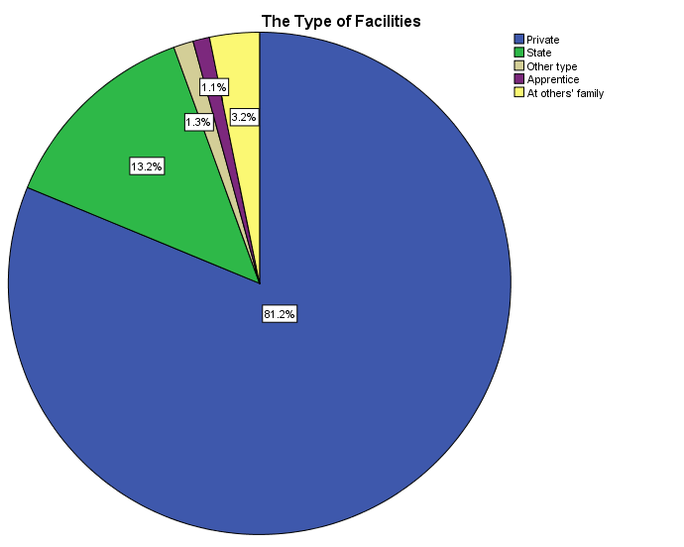

On the table #7 is disposed share of employed graduates by the enterprise / organization size.

**Table #7 -** the data of the hired workers according to the size of the facilities.

|  |  |  |
| --- | --- | --- |
|  | **Frequency** | **Percent** |
| 1 -20 | 253 | 53.7 |
| 21-100 | 112 | 23.8 |
| More than 100 | 84 | 17.8 |
| Missing | 22 | 4.7 |
| Total | 471 | 100 |

The portion of the hired workers, which had to change the place of residence because of the job, is very limited (see figure #9).

**Figure #9 -** Change of the place of residence by the hired workers for the job purposes (N=471)

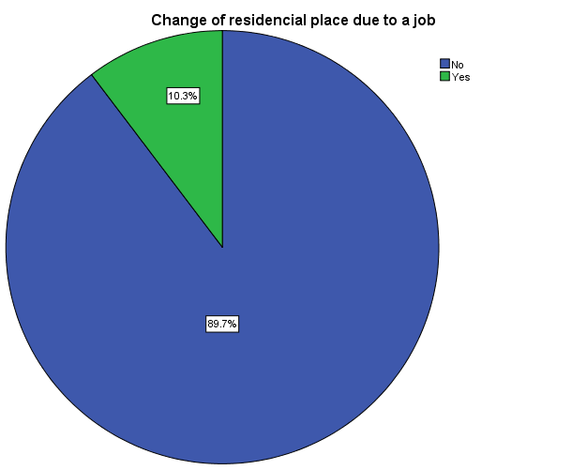

Only 1 out of 14 respondents which have own business, had to replace the city of residence / municipality to start own business. According to the data, the majority (53.9%) of the respondents owning business works alone. In case of 46.2% 1-20 persons are involved in their business (see figure #10).

**Figure #10 -** The number of the persons employed in own businesses (N=14)

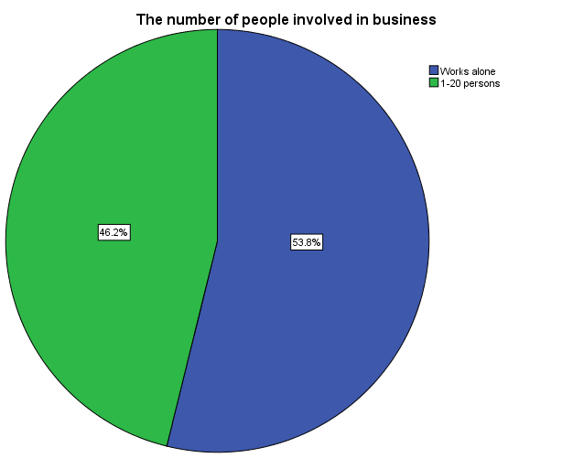

The survey showed, that among the graduates of vocational educational institutions 16 respondents are involved in small households. Only 2 respondents had to change the place of residence for the purpose of employment.

## Job search channels

It was important to learn, whether how available is information on employment for vocational programs graduates and to reveal what sources are the best to get this kind of information. According to study results, the graduates mostly receive information on employement from the vocational institutions thay study in (see Table #8).

**Table #8** – information / advice regarding the employment obtained from the vocational institutions.

|  |  |  |
| --- | --- | --- |
|  | **Frequency** | **Percent** |
| Information recived | 444 | 37% |
| Did not received an information | 762 | 63% |
| Total | 1206 | 100% |

The survey revealed the following trends: 212 respondents started job independently, which amounts to 43.3% of the employed persons in total. The job obtained with the help of the friends / acquaintances – 187 (38.2%); job offered at the place of practice – 33 respondents (6.7%); job started by the help of the college – 57 respondents (11.6%), and within the employment state center only 1 respondnet (see Table #9).

**Table #9** – the ways of job starting

|  |  |  |
| --- | --- | --- |
|  | **Frequency** | **Percent** |
| Job started independently | 212 | 43.3 |
| The job obtained with the help of the friends / acquaintances | 187 | 38.2 |
| Job offered at the place of practice | 33 | 6.7 |
| Job started by the help of the employment office of the college | 57 | 11.6 |
| Employment state center | 1 | 0.2 |
| Total | 490 | 100 |

The study showed, that the majority, 497 respondents out of 613 unemployed are seeking for the job, the rest 116 do not search for the job.

The respondents, which stated, that they do not search the job at the moment, named the reasons as well. The reason – “I have not decided yet what I would like to do” was stated by the male respondents mostly, than females, as well as the reason “I am going to rest”. As expected, one of the reasons for delaying the job searching is a military service stated by male respondents. Percentage distribution of this responds are given in the figure #11.

**Figure #11 -** The reasons whether they do not search for the job (N=116)

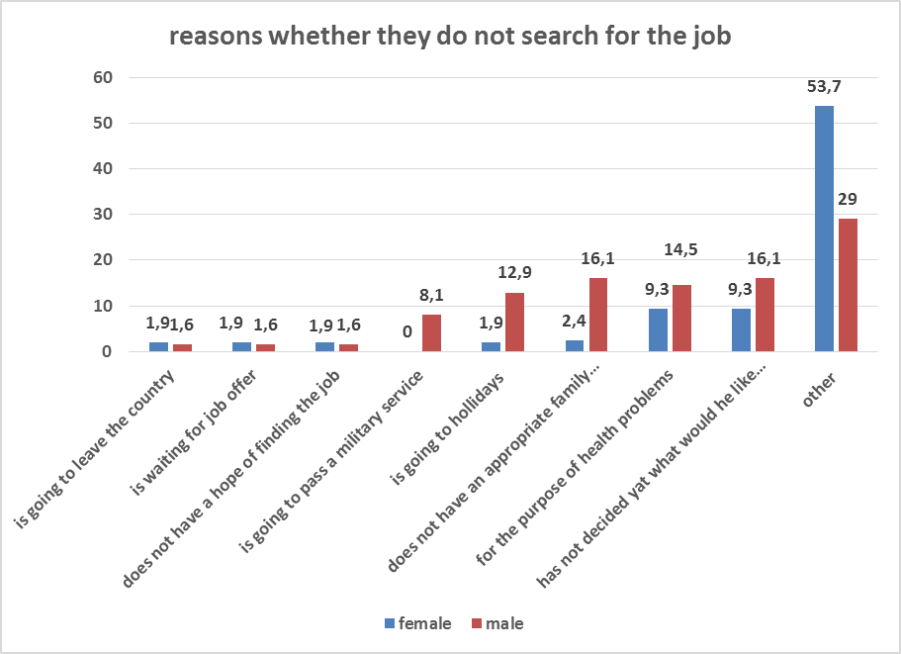

In addition to the responds provided on the figure, the respondents were able to give additional answers. According to this data analysis it is obvious, that the majority of women (53.7%) named pregnancy or having a child as a reason for not seeking the job. In case of males, the responds are more inhomogeneous. The main reasons stated by them are: having no desire, juvenile and a military service.

The respondents, who stated, that they were searching for the job, the reasons was that they could not find a job. As it is reflected on the figure below the reasons are limited demand on their profession, having no sufficient experience and the age, mostly listed by male respondents, rather than by females. Percentage distribution of the graduates according to the reasons by gender are provided in figure #12.

**Figure #12 -** The reasons, the graduates can’t find a job (N=497)

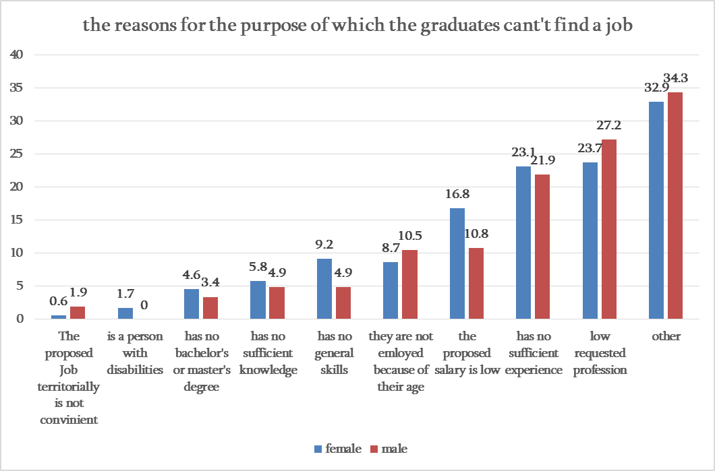

As for the information / advice received regarding the employment from the vocational institution, informational center, employment state center, employment private agency or practice place, the responds percentage and quantative distribution of the respondents is provided in Table #10.

**Table #10** – information / advice received regarding the employment

|  |  |  |
| --- | --- | --- |
|  | **Frequency** | **Percentage** |
| Information / advice received from the vocational institution | 220 | 32.5 |
| Information / advice on the employment received from informational center | 15 | 2.2 |
| Information / advice on the employment received from employment state center | 9 | 1.3 |
| Information / advice on the employment received from employment private agency | 12 | 1.8 |
| Information / advice on the employment received from practice place | 75 | 11.1 |
| Received no Information / advice on the employment | 346 | 51.1 |
| Total | 677 | 100 |

As it is shown in the table, the information / advice on employment was not received by more than a half – 346 (51.1%) respondents.

## Skills mismatch on the job

Approximately 42.6 % of employed respondents said that their work is fully or partially related to the specialty obtained at vocational school, while 57.4% said that his work is not related to the specialty.

It should be noted that the majority of the own business holders (61.6%) claims, that their business is fully or partially related to the specialty obtained at the vocational institution.

The majority of the respondents engaged in household activities consider, that there is not any connection between the profession obtained at vocational institution and their current activity. Only 3 respondents considered that their activity is partially linked to the profession obtained at vocational educational institution.

Out of 8 graduates, who undergo internship, 3 respondents state that the specialty obtained at vocational institution is linked, or is partially linked to the field with the internship field. 4 respondents state that they have internship at small-scaled private organization.

Combined data on this information is provided in table #11.

**Table #11**. Linkage of the job with the specialty obtained at vocational institution.

|  |  |  |
| --- | --- | --- |
|  | **Frequency** | **Percentage** |
| Is linked | 214 | 42% |
| Is not linked | 292 | 58% |
| Total | 506 | 100% |

## Need to acquire further skills and competencies

The survey studied what kind of knowledge and skills the graduates would like to improve. They evaluated the knowledge and skills to be improved by the scale of 1-3, accordingly, as close the average indicator to 3 is, more desirable is for them to improve the knowledge and skills. It revealed, that female respondents prefer to improve the knowledge and skills more than male respondents. The more detailed information is given at figure #13.

**Figure #13 -** the average indicator of skills improvement necessity evaluation according the gender

According to the analysis, the difference between women and men is reliable3 in case of the following answers: communication skills, management and organizational skills, team player skills, ability to act properly in problematic situation, professional practical skills, profession theoretical knowledge, planning and management skills (accordingly, F (1,1259) = 11.003, p= .001; F (1,1259) = 16.300, p= .000; F (1,1259) = 14.050, p= .000; F (1,1259) = 18.885, p= .000; F (1,1259) = 23.584, p= .000 F (1,1259) = 11.691 p= .000; F (1,1259) = 20.457, p= .000).

This kind of results can be explained by the fact that women are more active and despite the fact of obtaining education on equal levels and ability to reach the educational resources equally, the requirement of the knowledge improvement and skills strengthening is higher from the side of women.

## Income on the job

The income of majority of the respondents is 201-500 GEL, the significant part of the respondents have salary of up to 200 GEL and 501-1000 GEL. Income of 1001-2000 GEL mosty have the respondents in engineering field (see table #12).

**Table #12** – Income of the graduates according the fields[3]

|  |  |  |  |  |  |  |  |  |
| --- | --- | --- | --- | --- | --- | --- | --- | --- |
| Educational program | | | | | | | | Total |
| Earned income | Agricultural Sciences | Business Administration | Engineering | Science / Natural Sciences | Interdisciplinary fields and specialties | Art | Health care |
| Up to 200 | 12 | 4 | 41 | 0 | 6 | 10 | 3 | 76 |
| 201-500 | 23 | 15 | **112** | 1 | 32 | 25 | 1 | **209** |
| 501-1000 | 14 | 5 | **49** | 2 | 10 | 4 | 0 | 84 |
| 1001-2000 | 1 | 0 | **17** | 0 | 0 | 0 | 0 | 18 |
| More than 2000 | 0 | 0 | 0 | 0 | 0 | 1 | 0 | 1 |
| Did not receive a salary | 2 | 0 | 7 | 1 | 2 | 4 | 1 | 17 |
| No answer | 3 | 2 | 35 | 0 | 5 | 3 | 1 | 49 |
| Total | 55 | 26 | 261 | 4 | 55 | 47 | 6 | 454 |

Graduates income according gender is: up to 200 and 201-500 GEL is received by the female graduates, and also more women respondents did not receive the income within the last month. Male excess with 501-1000 and 1001-2000 GEL by income. Only one of the female respondent earns more than 2000 GEL. Gender distribution according the income of graduates is shown at figure #14.

**Figure #14 -** The income earned by the employed graduates according to the gender (N=454)

Percentage distribution of the earned income of the hired respondents is shown in the figure #15.

**Figure #15** - The income earned by the hired workers (N=424)

The income earned by the own business holders and the households for the last month is shown on the table #13.

**Table #13 -** Quantitative and percentage distribution of own business and household business holders according the income earned by them

|  |  |  |  |  |
| --- | --- | --- | --- | --- |
| **Income earned** | **Own business** | | **Household** | |
| **Frequency** | **Percent** | **Frequency** | **Percent** |
| Up to 200 | 2 | 14.3 | 1 | 6.3 |
| 201-500 | 5 | 35.7 | 5 | 31.3 |
| 501-1000 | 0 | 0 | 0 | 0 |
| 1001-2000 | 1 | 7.1 | 0 | 0 |
| More than 2000 | 0 | 0 | 2 | 12.5 |
| Did not receive salary | 0 | 0 | 4 | 25 |
| No answer | 4 | 28.6 | 4 | 25 |
| Missing | 2 | 14.3 | 0 | 0 |
| Total | 14 | 100 | 16 | 100 |

Families’ economical attitude on the income of the payable job employed (hired by the organization, private business and household) graduates were studied within the survey. In case of majority, 54.2% - the family partially depends on their income; in case of 26.3% depends on their income; fully dependable are 18.6% and 0.8% do not have families (see figure #16).

**Figure #16** - How is the family's well-being depends on the income of employed graduates (N=483)

## Job satisfaction

The study revealed, that the majority of the hired workers 62.3% (283 respondents) is satisfied with their jobs; 31.1% (141 respondents) is partially satisfied; is should be noted that only 6.6% (30 respondents) of the respondents are not satisfied with their jobs (see the figure #17).

**Figure #17 -** Satisfaction of the employed with their jobs (N=454)

58.3% of the respondents having own businesses are satisfied with their business.41.7% respondents are partially satisfied; negative answer was not received at all (see table #14).

**Table #14** – quantitative and percentage distribution according the satisfaction with the own businesses.

|  |  |  |
| --- | --- | --- |
|  | **Frequency** | **Percent** |
| Yes | 7 | 58.3 |
| Partially | 5 | 41.7 |
| Total | 12 | 100 |

Graduates, which are engaged into the household businesses were asked whether they were satisfied with their businesses, the responds were located as follows: positive answer was fixed by 8 respondents (50%); partially satisfied were 7 (43.8%) and unsatisfied only 1 respondent.

Common data for all types of employed are following: 89% is fully or partially satisfied with own activity, but the rest 11% - unsatisfied.

## Conditions of work

As a result of survey the following was revealed: 56.5% of the hired worker respondents (266 respondents) work fulltime; Part-time – 13.8% (65 respondents); 23.8% (112 respondents) work as required. And the response “other” was stated by 2.3 % (see table #15).

**Table #15** – Distribution of the respondents hired by the organization according the work schedule

|  |  |  |
| --- | --- | --- |
|  | **Frequency** | **Percent** |
| Full time | 266 | 56.5 |
| Part time | 65 | 13.8 |
| Per demand | 112 | 23.8 |
| Other | 11 | 2.3 |
| Do not know | 1 | .2 |
| Missing | 16 | 3.4 |
| Total | 471 | 100 |

The types of labor agreements of hired workers, own business holders work schedule and stability / intensivity of the respondnets engaged in household businesses were determined according the survey. This data are provided in the tables #16, #17 and #18.

**Table #16** – Distribution of the respondents hired by the organization according the labor agreement types

|  |  |  |
| --- | --- | --- |
|  | **Frequency** | **Percent** |
| Permanent | 94 | 20 |
| Temporary | 116 | 24.6 |
| Seasonal | 6 | 1.3 |
| The term is not defined | 75 | 15.9 |
| No agreement | 144 | 30.6 |
| Do not know | 20 | 4.2 |
| Missing | 16 | 3.4 |
| Total | 471 | 100 |

**Table #17** – The quantitative and percentage distribution of respondents having the own businesses according the working Schedule

|  |  |  |
| --- | --- | --- |
|  | **Frequency** | **Percent** |
| Full time | 2 | 14.3 |
| Part time | 2 | 14.3 |
| As required | 8 | 57.1 |
| Missing | 2 | 14.3 |
| Total | 14 | 100 |

**Table #18** – The quantitative and percentage distribution of work schedule stability / intensivity of the respondents engaged in household businesses

|  |  |  |
| --- | --- | --- |
|  | **Frequency** | **Percent** |
| Permanent | 7 | 43.8 |
| Temporary | 2 | 12.5 |
| Seasonal | 4 | 25.0 |
| Do not know | 3 | 18.8 |
| Total | 16 | 100 |

1. *all the data is counted according the observed answers here and below*
2. *Respondents could choice maximum 3 activities. Consequently, the indicators of the question is estimated by the number of responses given by respondents.*
3. *There, as well as in other cases, the data is analyzed without missing answers.* 